**Parsing JSON in Java**

This document provides instructions of how to parse JSON in Java. JSON stands for Java Script Object Notation and it is a common format of web service output.

In following code snippet, an HTTP request is sent to tinysong web service, which is a RESTful service, and a JSON formatted result is returned.

String query="Usher";String key = "0306a279dcf01f196621c6ccca3b11a8";

URL url = **new** URL("http://tinysong.com/s/" + query +"?format=json&key=" + key);

HttpURLConnection connection =(HttpURLConnection) url.openConnection ();

connection.setRequestMethod("GET");

connection.connect();

BufferedReader bufferReader = **new** BufferedReader(**new** InputStreamReader (connection.getInputStream()));

String str;

StringBuffer stringBuffer = **new** StringBuffer();

**while** ((str = bufferReader.readLine()) != **null**) {

stringBuffer.append(str);

stringBuffer.append("\n");

}

System.*out*.println(stringBuffer.toString());

str = stringBuffer.toString();

To parse a Json result stored in str,

**Step 1: Add JSON library to the project:**

* Download json.simple library (.jar ) file from here :[Link](https://code.google.com/p/json-simple/downloads/detail?name=json-simple-1.1.1.jar&can=2&q=)
* Right click over the project tree structure
* Click on Project Properties
* Click on Libraries
* Click on Add JAR/Folder
* Browse and find the place where you downloaded the json.simple JAR
* Add the Jar file

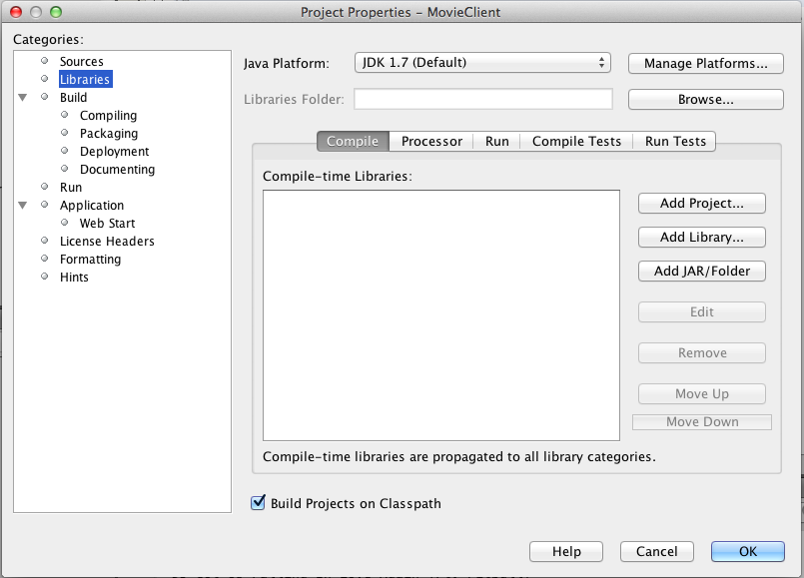

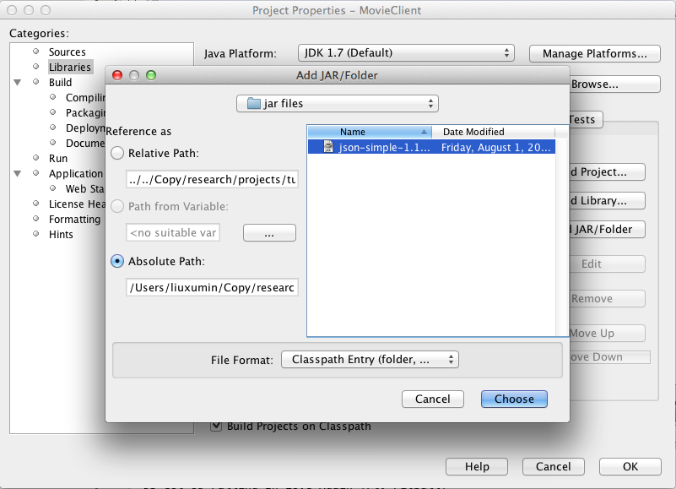

**Step 2: Create and use the JSON parser:**

* Create JSON parser

JSONParser parser = **new** JSONParser();

* Parse str .

Object obj = parser.parse(str);

* As str is an array of records, a JSONArray is created. We cast the Object into JSONArray.

JSONArray msg = (JSONArray) obj;

* The JSONArray corresponds to a Map structure in java so we create an iterator to loop through it. Inside the JSONArray we have JSONObjects separated by commas. We set the next item from the JSONArray to be a JSONObject and perform a get Operation using the key

Iterator<?> iterator = msg.iterator();

JSONObject a ;

**while** (iterator.hasNext()) {

a=(JSONObject)iterator.next();

System.*out*.println(a.get("SongName"));

}

Output result:

DJ Got Us Falling In Love Again [Ft. Pitbull]

Good Kisser

OMG (Ft Will.I.Am)

You Remind Me

NICKI MINAJ FT CHRIS BROWN - RIGHT BY MY SIDE

Black Black Heart 2.0

Burn

Confessions, Part 2

Yeah! (feat. Usher & Ludacris)