## Introduction to

# Microsoft Access 2010

Microsoft Access is a Relational Database Management System (RDBMS) for desktop databases providing data definition, data manipulation, and data control functions for large amounts of data. It also provides an application development system through forms, reports, macros, and a Web interface in conjunction with SharePoint Server 2010. One can import into MS Access data from many other databases.

# Microsoft Access 2010

# Lab 1

# Creating Databases

In this lab we will look at the basics of Microsoft Access and particularly its user interface. You should first read the information given in this practical and then complete the activities listed throughout.

**Starting and Quitting Microsoft Access**

**To start Microsoft Access**

Click on the Windows **Start** button; select **Programs**, then **Microsoft Office** then **Access**.

Or, if displayed on the screen, double-click on the **Microsoft Access icon**. 

**To quit Microsoft Access**

Choose **Exit** from the **File** menu.

**Getting Help using Microsoft Access**

There are many ways to get assistance when using Microsoft Access. Many of the help options are available through the **Help** menu from the **File** menu or by selecting the Microsoft Access Help button on the toolbar.



**Access Wizards**

When you create a new database, table, query, form or report, Microsoft Access provides the possibility of choosing whether to start with a blank object and build it yourself or use an Access Wizard to help you build it. An Access Wizard is like a database expert who prompts you with questions about the object you want and then builds the object based on your answers.

***Activity P1-1***

Practice using the Microsoft Access help facilities. Search for help or ask questions on the following topics: creating tables, data types, primary key, referential integrity, data validation and the web publisher wizard.

**User interface**

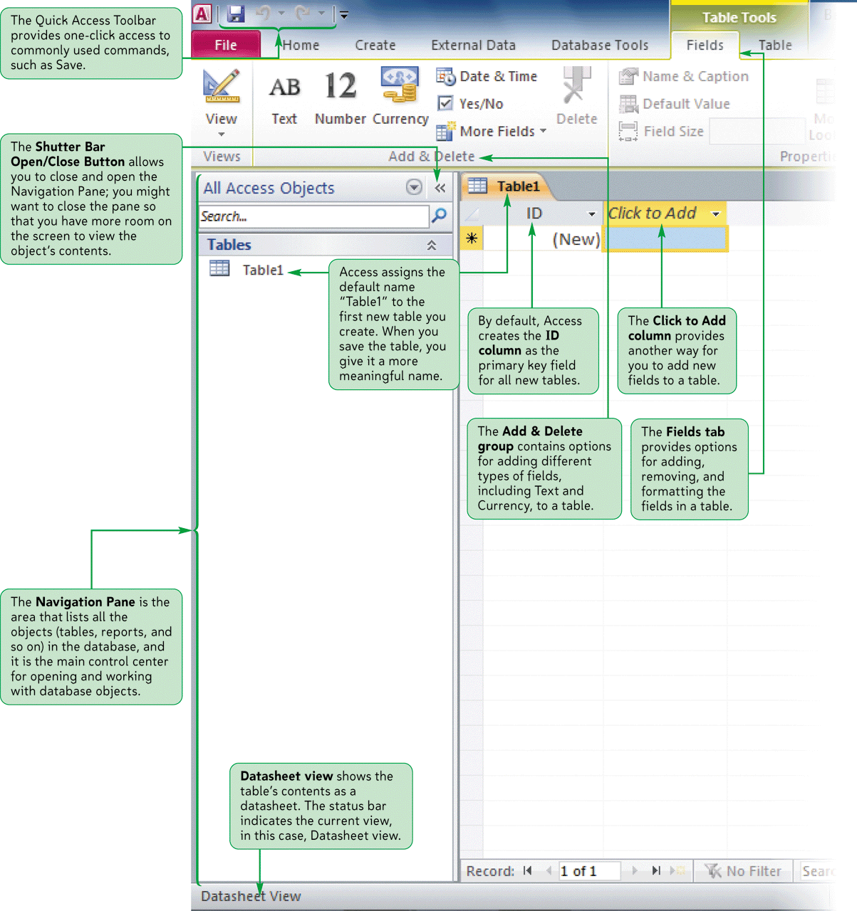

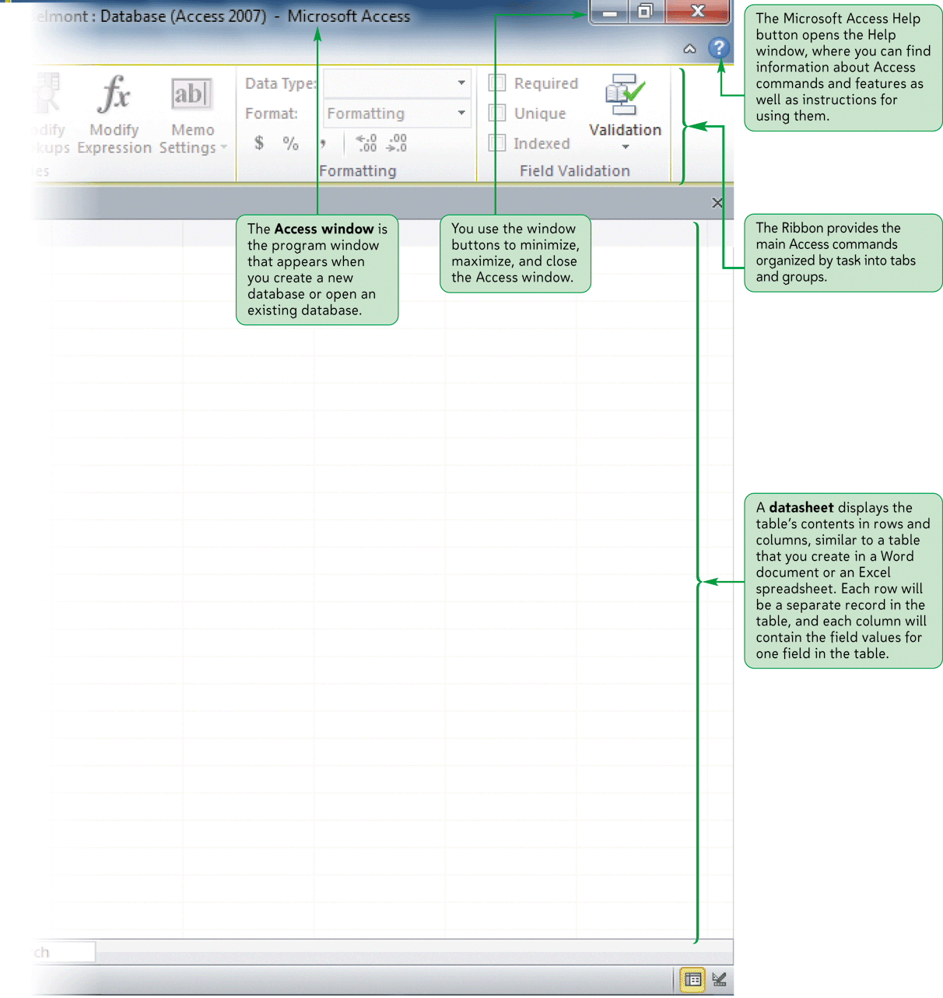

**Figure P1-1**

Figure P1-1 shows in particular:

* The **Access Window** and its Window buttons to minimize, maximize, and close the window,
* the **Quick Access toolbar** with one-click access to frequent tasks, such as Save, Undo, and Redo,
* the **Tabs** for quick access to the File menu and other menus.
* the **Ribbon** with tools to select by task,
* the **Shutter Bar** with Open and Close button for the Navigation Pane,
* the **Navigation Pane** where to select database objects,
* the **datasheet** display where data are displayed.

**Opening a Database**

A Microsoft Access database is a collection of objects, not just a single table of data. One database file contains the tables as well as queries, forms, reports and other objects that help

you use the information in the database.

The extension for MS Access databases is usually **.accdb**. However MS Access opens databases created with earlier versions of Access which are usually in **.mdb** format.

When you first load Access, the Microsoft Access **Backstage view** is displayed, as shown in Figure P1-2.

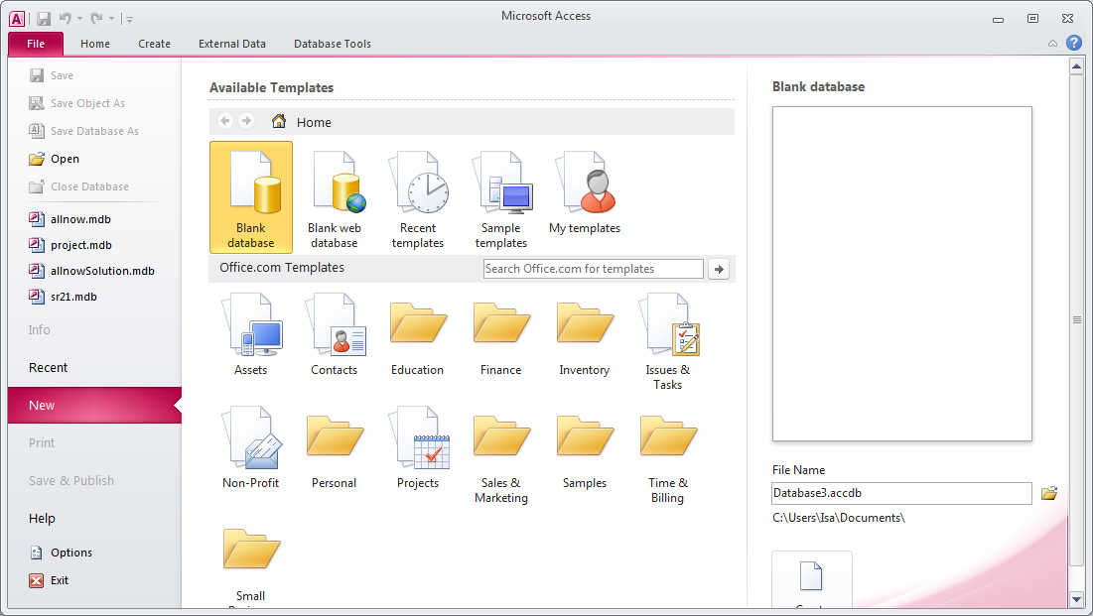

**Figure P1-2: The Microsoft Access Backstage view.**

**To Open a Database using Microsoft Access Backstage view**

The most recently opened databases are listed below the **Open** option – for example here **allNow.mdb**. To view existing databases not recently accessed, select the **Open** option. The window opens a file browser where you can navigate to a folder containing existing databases. Once you have made your selection click on **Open** to continue or **Cancel** to cancel the operation.

**To Open a Database**

If the Microsoft Accessdialog box is not displayed choose **Open** from the **File** menu.

This displays the Open dialog box. Once you have located your database and identified the file name, choose **Open**. Microsoft Access provides sample databases through its **templates** library.

**The Database Window**

When you create or open a database, Microsoft Access displays a Database window in the Microsoft Access window. The Database window is your command center. From here, you can create, edit and use any object in your database. For example, the Database window for the **allNow** database, is shown in Figure P1-3.

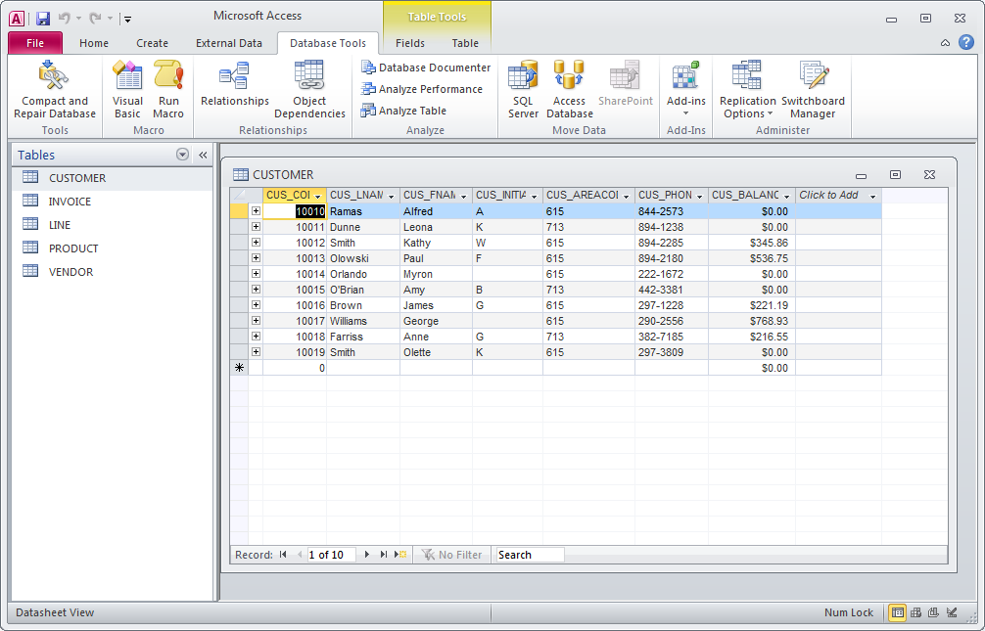

**Figure P1-3: The Microsoft Access Database window for the allNow database.**

The object buttons in the Database window provide direct access to every object in your database. For example, to see a list of forms in the database, click the **Forms** button. Microsoft Access displays the list of forms stored in the database. To return to the list of tables, click the **Tables** button.

**Viewing Data and Closing a Database**

**To view data in a table**

1. In the Database window, click the **Tables** button to display the list of tables in the database.

2. Double-click the name of the table you want to see.

Microsoft Access displays the table in **Datasheet** view. Datasheet view displays data from the table in columns and rows, similar to a spreadsheet. In a datasheet, you can resize and rearrange the columns (fields) and resize the rows (records). You can scroll vertically to see more records and horizontally to see more fields.

**To view data using a form**

1. In the Database window, click the **Forms** button to display the list of forms.
2. Double-click the name of the form you want to view. Microsoft Access opens the form and displays the first record of data.

**To close a database**

1. Switch to the Database window if it isn’t active.

2. From the **File** menu, choose **Close**.

***Activity P1-2***

Open a database from a template – for example from the **Education** template, the **Desktop Student Database**. Close the database and exit Access.

**Creating a Database**

When you create a Microsoft Access database, you create one file that contains all the tables in your database as well as the queries, forms, reports and other objects that help you use the information in the database.

Microsoft Access provides two methods to create a database. You can create a blank database and then add the tables, forms, reports and other objects later and this is the most flexible method, but it requires you to define each database element separately. Or you can use a Database Template to create in one operation the required tables, forms and reports for the type of database you choose and this is the easiest way to start creating your database. Either way, you can modify and extend your database at any time after it has been created.

In the following sections, we describe how to create a database from scratch. We will take example on the **DreamHome** database.

### To create a database using a Template

1. In the Microsoft Access startup window, choose **New** from the **File** menu.
2. The **New** dialog box is displayed. Choose the **Template** option corresponding most closely to the database that you want to create. To select the database you need, double-click the icon. This will create what you need to store, enter and summarize your data.

**To create a database (without Database Template)**

1. In the Microsoft Access startup window, choose **New** from the **File** menu. Or click the New button on the toolbar.

Click on the **Blank Database** icon. You can type the name of the database (**DreamHome.accdb**) in the **File name** box. A database name can contain up to 64 characters. Microsoft Access automatically appends an **accdb** extension to your database filename. You can also choose the folder where you want to save it in the bottom right of the screen.

Click **Create**.

2. To save the database, after closing all objects (tables), choose **Save Database As** or **Save** from the **File** menu.

3. To store the database in a different directory or drive, select the location of the file you want in the **Save in** list.

***Activity P1-3***

Create a new blank database called DreamHome.accdb and save it to your network folder or personal drive. This database will hold the tables, forms, reports and other objects for a real estate rental company.