# Assignment #2

**(due on Wednesday, October 17, 2012)**

The conceptual model of a view of the DreamHome database is provided below.

**Use-case Diagram**

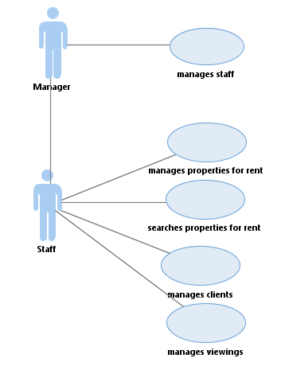

**Entity-relationship Diagram**

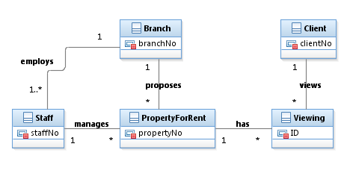

# Data Dictionary

|  |  |  |  |
| --- | --- | --- | --- |
| Entity name | Description | Aliases | Occurrence |
| Branch | General item describing all branches operated by DreamHome |  |  |
| Client | General item describing all clients of DreamHome | customer | Each client can view many properties at different times |
| PropertyForRent | General item describing all properties for rent proposed by DreamHome | property | Each property has a single owner and is available at one specific branch, where it is managed by one staff member. A property is viewed by many clients and rented by a single client at any one time |
| Staff | General item describing all staff employed by DreamHome | employee | Each staff member works at one particular branch |
| Viewing | General item describing all viewings of properties by clients of DreamHome | visit |  |

|  |  |  |  |  |
| --- | --- | --- | --- | --- |
| Entity name | Multiplicity | Relationship | Multiplicity | Entity name |
| Branch | 1..1 | employs | 1..* | Staff |
|  | 1..1 | proposes | 0..* | PropertyForRent |
| Staff | 1..1 | manages | 0..* | PropertyForRent |
| PropertyForRent | 1 | has | 0..* | Viewing |
| Client | 1 | views | 0..* | Viewing |

|  |  |  |  |  |  |
| --- | --- | --- | --- | --- | --- |
| Entity name | Attributes | Description | Data type & length | Nulls | Multi-valued |
| Branch | branchNo | Uniquely identifies a branch | 5 variable characters | No | No |
|  | street | Street address | 50 variable characters | No | No |
|  | city | City name | 50 variable characters | No | No |
|  | postcode | Zip code | 10 variable characters | No | No |
| Client | clientNo | Uniquely identifies a branch | 5 variable characters | No | No |
|  | fName | First name | 50 variable characters | No | No |
|  | lName | Last name | 50 variable characters | No | No |
|  | telNo | Telephone number | 20 variable characters | No | No |
|  | street | Street address | 50 variable characters | No | No |
|  | city | City name | 50 variable characters | No | No |
|  | postcode | Zip code | 10 variable characters | No | No |
|  | email | Email address | 40 variable characters | No | No |
|  | joinedOn | Date when joined | Date/time | No | No |
|  | region | Area client is interested in | 30 variable characters | No | No |
|  | preType | Preferred property type | 10 variable characters | No | No |
|  | maxRent | Maximum rent amount | Integer | No | No |
| PropertyForRent | propertyNo | Uniquely identifies a property | 5 variable characters | No | No |
|  | street | Street address | 50 variable characters | No | No |
|  | city | City name | 50 variable characters | No | No |
|  | postcode | Zip code | 10 variable characters | No | No |
|  | type | Property type | 10 variable characters | No | No |
|  | rooms | Number of rooms | Integer | No | No |
|  | rent | Number of rooms | Integer | No | No |
|  | ownerNo | Property number id | 5 variable characters | No | No |
|  | staff No | Staff id | 5 variable characters | No | No |
|  | branchNo | Branch id | 5 variable characters | No | No |
|  | picture | Property picture | Image | No | No |
|  | floorPlan | Floor plan map | Image | No | No |
| Staff | staffNo | Uniquely identifies a staff | 5 variable characters | No | No |
|  | fName | First name | 50 variable characters | No | No |
|  | lName | Last name | 50 variable characters | No | No |
|  | position | Staff position | 20 variable characters | No | No |
|  | sex | Gender | Boolean | No | No |
|  | dob | Data of birth | Date/Time | No | No |
|  | salary | Annual salary | Single precision floating point | No | No |
|  | branchNo | Branch id | 5 variable characters | No | No |
|  | telephone | Telephone number | 20 variable characters | No | No |
|  | mobile | Mobile phone number | 20 variable characters | No | No |
|  | email | Email address | 40 variable characters | No | No |
| Viewing | id | Uniquely identifies a viewing | Integer autonum | No | No |
|  | clientID | Client id | 5 variable characters | No | No |
|  | propertyNo | Property id | 5 variable characters | No | No |
|  | viewDate | Date of viewing | Date | No | No |
|  | viewHour | Hour of viewing | 5 variable characters | No | No |
|  | comment | Client comments | 255 variable characters | No |  |
|  | wishToRent | Client decision to rent or not | Boolean | No | No |

The goal of this assignment is to build a logical model of this view in MS Access 2010.

1. Create the tables, fields, and relationships in Access described in the conceptual model.
2. Generate the documentation of this Access database, selecting all five tables, as an **rtf** or **Word file** and upload it to Angel drop box. Name this file **documentation.rtf** or **documentation.docx**. The Access Documenter is available under the **Analyze** tool of **Database Tools**. The options to choose are indicated in the figures below.

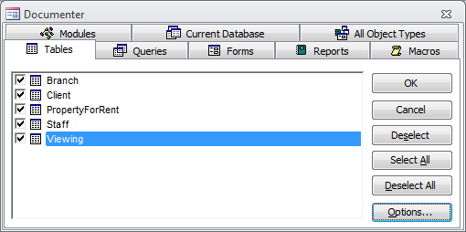

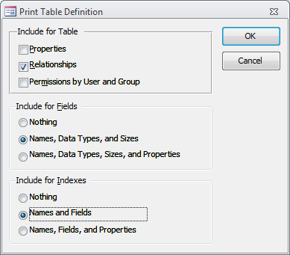

1. Capture a screenshot of the relationships view of the Access database. It should look like the figure above (hint: to take a screenshot, click on **ALT** and **Printscreen** keys at the same time, then paste in a Word document with CTRL+V). Name this file **relationships.docx**.
2. Create an Access form representing the list of staff per branch in the database. The form should have the elements represented below.

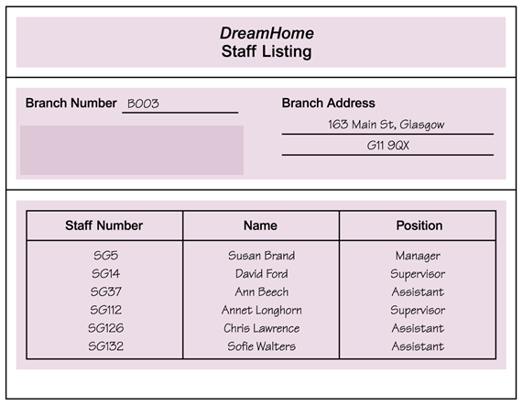

1. Paste in a Word document a screenshot of the form in **Print preview**. Below the form, provide a list of the relations and attributes used in this form, represented in the form **relation1(attribute1, attribute2, attribute3, attribute4)**, where **relation1** is the table name, **attribute1** is the primary key, and **attribute2, attribute3,** … are fields in the table. This document should be named **form.docx**.
2. Upload on Angel the three files
   1. **documentation.docx (40 points)**,
   2. **relationships.docx (20 points)**, and
   3. **form.docx (40 points)**.