# Assignment #3

**(due on Wednesday, November 7, 2012)**

Use the SALES database from the class Web-site (<http://cs.oswego.edu/~bichinda/isc329/sales.mdb>) to solve all the following problems in MS Access. Each question is worth 10 points.

**Preparation**

Load the *sales* database in Access (by simply clicking on sales.mdb).

**To create a query:** select the *Create* tab, then *Query Design*. Following, close the popped up screen, and select *SQL View* from the *SQL* icon (you want to enter your queries as SQL statements).

**To run a query:** click on the red exclamation mark (*Run*).

**To save a query:** you will be prompted for a name for your query when closing its window.

**Required turn-in**

For each question, paste in this document the SQL query, followed by the screen output in Access.

**FIGURE 1 - The SALES Database’s Relational Schema**

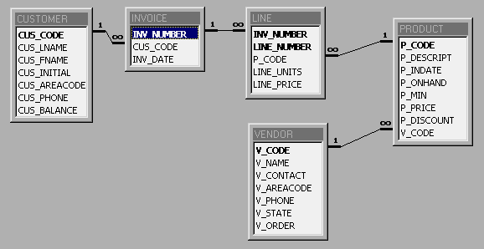

**QUESTION I**

Write a query that displays for each customer their customer code, name, and total balance (from Customer table).

**QUESTION II**

Write a query that displays for each customer their customer code, name, total balance (from Customer table), and their total purchases (from Invoice). This column can be called Total_purchases for instance. Note that the invoice total is calculated by multiplying the number of products bought (LINE_UNIT) by the price of each product (LINE_PRICE).

**QUESTION III**

Write a query that displays for each customer their customer code, name, total balance (from Customer table), their total purchases (from Invoice), and the number of individual products they purchased (if the customer’s invoice is based on three products, one per LINE_NUMBER, you are counting three individual product purchases). Call this column for instance Number_of_purchases.

**QUESTION IV**

Add to the preceding query the average purchase amount per product made by each customer, using a subquery and a column name such as Average_purchase_amount.

**QUESTION V**

Write a query that generates the total number of invoices, the invoice total for all of these invoices (total sales), the smallest invoice amount, the largest invoice amount, and the average of all the invoices.

**QUESTION VI**

Create a query to produce the total purchase per invoice to generate a listing showing only invoice numbers and invoice totals. The Invoice Total is the sum of the product purchases in the LINE that correspond to the INVOICE.

**QUESTION VII**

Use a query to show the invoice numbers and invoice totals, and also the corresponding customer codes, ordered by customer code. (Hint: Group by the CUS_CODE.).

**QUESTION VIII**

List the balance characteristics of the customers who have made purchases during the current invoice cycle -- that is, for the customers who appear in the INVOICE table.

**QUESTION IX**

Based on query 8, list minimum balance, maximum balance, and average balance across all customers who made purchases during the current invoice period.

**QUESTION X**

Create a query to find customer balance characteristics for all customers, including total balance, minimum balance, maximum balance, and average balance.

**EXTRA CREDIT**

Using the query results in Problem 11 as your basis, write a query to generate the total number of invoices, the invoice total for all of these invoices (total sales), the smallest invoice amount, the largest invoice amount, and the average of all the invoices. (10 points)