# Assignment #4

**(due on Sunday, December 2, 2012)**

The goal of this assignment is to create a database application allowing for the retrieval of DreamHome branch and employee information.

**Preparation**

Load the *DreamHome* database in Access (by simply clicking on *dreamhome.mdb* found on the class Web-site next to this assignment).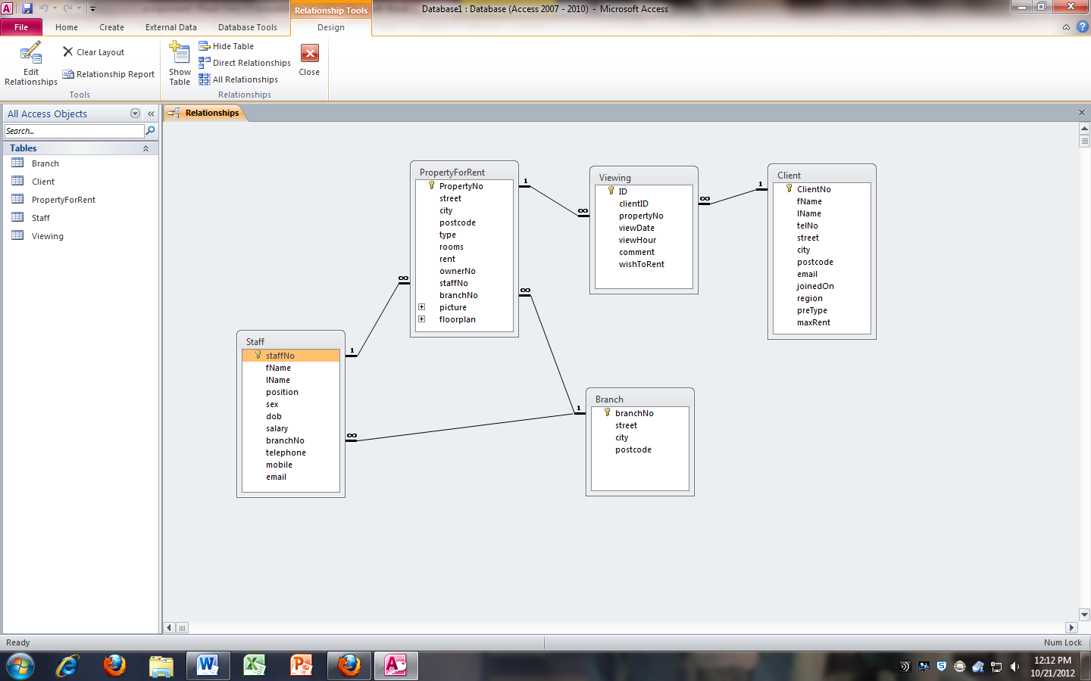

**FIGURE 1 - The DREAMHOME Database’s Relational Schema**

**QUESTION I**

Import the *DreamHome* database schema and content in MySQL server in *moxie* using the database named *2012_username*. One possibility is to use “Access to MySQL” from bullzip.com (choose the *Create dump file* option). Check whether all keys and in particular foreign keys have been created. If they have not been, add them in the file before FTPing the file to *moxie* and creating the tables in MySQL (using the *source* command).

**Turn In**

Paste here a screenshot of the tables imported in MySQL (SHOW TABLES).

**QUESTION II**

Create a PHP script prompting the user for a branch number and returns either an error message if the branch number does not exist in the database, or the list of staff working at that branch as provided in Figure 2.

**FIGURE 2 - The DREAMHOME Staff Listing Form**

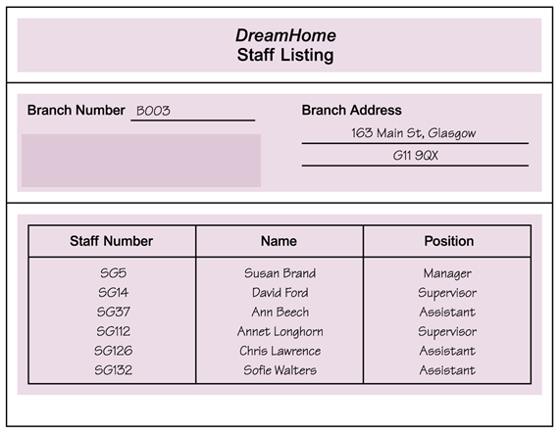

**Turn In**

Paste here a screenshot of the form with data retrieved for branch number B003.

**QUESTION III**

Provide the link to your form on moxie.

**Turn In**

Paste here the link.