**First Name:____________ Last Name:____________________________ID:**

**Second Midterm**

**Part I (20%, each question is worth 1 point)**

Check the letter of the choice that best completes the statement or answers the question.

1. The SQL command that lets you insert data into a table, one row at a time, is (check only one):
2. commit.
3. insert.
4. select.
5. update.
6. The SQL command that lets you save your work to disk, is (check only one)
7. insert.
8. rollback.
9. commit.
10. update.
11. To list all the contents of a PRODUCT table you would use (check only one)
12. LIST * FROM PRODUCT;
13. SELECT * FROM PRODUCT;
14. DISPLAY * FROM PRODUCT;
15. SELECT ALL FROM PRODUCT;
16. To restore the table contents, the command to be used is (check only one)
17. commit; rollback;
18. rollback;
19. commit; restore;
20. commit; backup;
21. The basic SQL aggregate function that gives the total of all values for a selected attribute in a given column is (check only one)
22. COUNT.
23. MIN.
24. SUM.
25. AVG.
26. Database security measures should target (check only one)
27. Confidentiality of the data.
28. Integrity of the data.
29. Database backup and recovery.
30. All of the above.
31. The coding, testing, and debugging are part of the (check only one)
32. Maintenance phase.
33. Analysis phase.
34. Detailed systems design phase.
35. Implementation phase.
36. The database contents are loaded using a variety of methods and devices such as (check only one)
37. A database interface program.
38. Conversion programs that import data from a different file structure.
39. A customized user program.
40. All of the above.
41. Creating the conceptual design, DBMS software selection, creation of the logical design, and creating the physical design are part of the (check only one)
42. Database initial study phase.
43. Database design phase.
44. Implementation and loading phase.
45. Testing ad evaluation phase.
46. All transaction properties must display (check only one)
47. Durability and isolation.
48. Serializability, durability, and isolation.
49. Atomicity, serializability, and durability.
50. Atomicity, durability, serializability, and isolation.
51. A lock that locks the entire table preventing access to any row by a transaction while another transaction is using the table is referred to as a (check only one)
52. Database-level lock.
53. Table-level lock.
54. Page-level lock.
55. Row-level lock.
56. A lock that specifically reserves access for the transaction that locked the object is known as a(n) (check only one)
57. Shared lock.
58. Exclusive lock.
59. Binary lock.
60. Two-phase lock.
61. A condition that occurs when two transactions wait for each other to unlock data is known as (check only one)
62. Two-phase lock.
63. Binary lock.
64. Deadlock.
65. Shared lock.
66. The technique(s) to control deadlocks are (check only one)
67. deadlock detection
68. deadlock avoidance
69. deadlock prevention
70. all of the above
71. none of the above
72. The two-phase locking protocol is governed by the following rule(s) (check only one)
73. Two transactions can have conflicting locks.
74. No unlock operation can precede a lock operation in a different transaction.
75. No data are affected until all locks are released.
76. All of the above.
77. None of the above.
78. What feature is a DDBMS disadvantage (check only one)
79. Data are located near the “greatest demand” site.
80. Security.
81. Reduced operating costs.
82. Processor independence.
83. What feature is a DDBMS advantage (check only one)
84. Greater difficulty in managing the data environment.
85. Increased storage requirements.
86. Less danger of a single-point failure.
87. Complexity of management and control.
88. Methods for securing a Microsoft Office database may involve (check only one)
89. Locking the database server.
90. Defining user level security.
91. Requiring a password to access the database.
92. All of the above.
93. Which is NOT a rule to create a DBMS system (check only one)
94. The system must be able to recover from hardware failures.
95. The system must be able to recover from software failures.
96. The system must support types and classes.
97. Data query must be simple.
98. RAID technology presents all the following advantages EXCEPT (check only one)
99. Less redundant components.
100. Increased performance.
101. Increased reliability.
102. More redundant components.

**Part II (60%, each question is worth 20 points)**

**1. Write a SQL command to create the EMPLOYEE table, with following attributes. The primary key is EMP_NUM, and the table has JOB_CODE as a foreign key to the JOB table.**

|  |  |
| --- | --- |
| **Attribute (Field) Name** | **Data Declaration** |
| EMP_NUM | CHAR(3) |
| EMP_LNAME | VARCHAR(15) |
| EMP_FNAME | VARCHAR(15) |
| EMP_INITIAL | CHAR(1) |
| EMP_HIREDATE | DATE |
| JOB_CODE | CHAR(3) |

**2. Given the following database schema:**

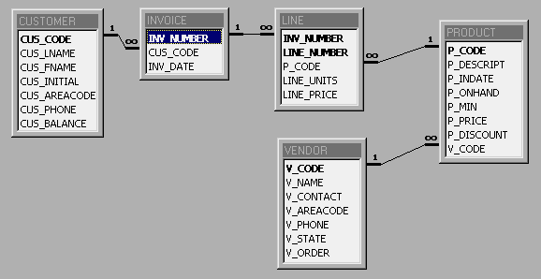

Write a SQL command to produce the listing of customer balance for each customer, and his/her total purchases.

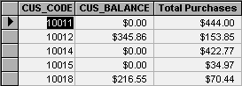

**3. Given the same database schema as in question 3., find the listing of customers who did not make purchases during the invoicing period. Your output must match the output shown on Figure 1.**

**FIGURE 1. The Customer Balance Characteristics for Customers Who**

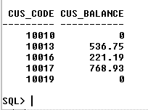**Did Not Make Purchases During the Invoice Period**