**First Name:____________ Last Name:____________________________ID:**

**Final**

**Part I (20%, each question is worth 1 point)**

1.b

2.c

3.b

4.b

5.c

6.d

7.d

8.d

9.b

10.d

11.b

12.b

13.c

14.d

15.e

16.b

17.c

18.d

19.c

20.a

**Part II (80%, each question is worth 20 points)**

**1. Write a SQL command to create the EMPLOYEE table, with following attributes. The primary key is EMP_NUM, and the table has JOB_CODE as a foreign key to the JOB table.**

|  |  |
| --- | --- |
| **Attribute (Field) Name** | **Data Declaration** |
| EMP_NUM | CHAR(3) |
| EMP_LNAME | VARCHAR(15) |
| EMP_FNAME | VARCHAR(15) |
| EMP_INITIAL | CHAR(1) |
| EMP_HIREDATE | DATE |
| JOB_CODE | CHAR(3) |

CREATE TABLE EMP_1 (

EMP_NUM CHAR(3) NOT NULL,

EMP_LNAME CHAR(15 NOT NULL,

EMP_FNAME CHAR(15) NOT NULL,

EMP_INITIAL CHAR(1),

EMP_HIREDATE DATE NOT NULL,

JOB_CODE CHAR(3),

PRIMARY KEY (EMP_NUM),

FOREIGN KEY (JOB_CODE) REFERENCES JOB);

**2. Given the following database schema:**

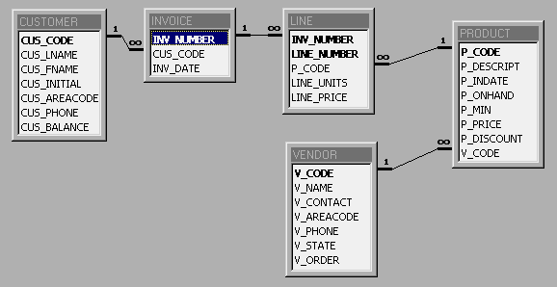

Write a SQL command to produce the listing of customer balance for each customer, and his/her total purchases.

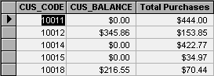

SELECT CUSTOMER.CUS_CODE, CUS_BALANCE, SUM(LINE_UNITS*LINE_PRICE)

FROM CUSTOMER, INVOICE, LINE

WHERE CUSTOMER.CUS_CODE = INVOICE.CUS_CODE AND

INVOICE.INV_NUMBER = LINE.INV_NUMBER

GROUP BY CUSTOMER.CUS_CODE, CUS_BALANCE;

**3. Given the same database schema as in question 3., find the listing of customers who did not make purchases during the invoicing period. Your output must match the output shown on Figure 1.**

**FIGURE 1. The Customer Balance Characteristics for Customers Who**

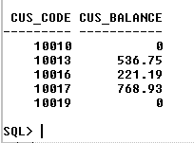**Did Not Make Purchases During the Invoice Period**

SELECT CUS_CODE, CUS_BALANCE

FROM CUSTOMER

WHERE CUS_CODE NOT IN (SELECT UNIQUE CUS_CODE FROM INVOICE);