First Name:____________ Last Name:____________________________ID:

Midterm

Part I (40%, each question is worth 2 points)

Check the letter of the choice that best completes the statement or answers the question.

- A relational database data is organized as (check only one)
- elements.
- a collection of records.
- tables.
- a collection of common fields.

- A field, or a combination of fields, that has a unique value is a (check only one)
- secondary key.
- foreign key.
- primary key.
- alternate key.

- A foreign key must (check only one)
- be defined in all tables in the database.
- be numeric.
- match the field value of a primary key in a related table.
- be unique.

- DBMS performs several important functions that guarantee the integrity and consistency of the data in the database. Which of the following is NOT one of those functions? (check only one)
- Storage management.
- Data reports.
- Security management.
- Directory management.

- The hierarchical database model depicts a set of _______________relationship (check only one)
- many to one.
- one to many.
- one to one.
- many to many.

- The entity integrity rule requires that (check only one)
- all entries are unique.
- foreign key values do reference primary key values.
- a part of the key may be null.
- duplicate object values are allowed.

- The term first normal form (1NF) describes the tabular format in which (check only one)
- all the key attributes are defined.
- there are no repeating groups in the table. Row/column intersection can contain one and only one value, not a set of values.
- all attributes are dependent on the primary key.
- all of the above.

- The referential integrity rule requires that (check only one):
- it makes it possible for an attribute to have a corresponding value.
- every null foreign key value must reference an existing primary key value.
- every non-null foreign key value must reference an existing primary key value.
- it makes it possible to delete a row in one table whose primary key does not have a matching foreign key value in another table.

- Each table must have (check only one):
- A primary key.
- A secondary key.
- A foreign key.
- A logical key.

- A Relational operator that yields all possible pairs of rows from two tables is known as a (check only one)
- union
- product
- join
- project

- An attribute (or combination of attributes) used strictly for data retrieval purposes is called a (check only one)
- superkey
- candidate key
- secondary key
- primary key

- A Relational operator that allows for the combination of information from two or more tables is known as a (check only one)
- union.
- joign.
- difference.
- product.

- Cardinality expresses __________ number of entity occurrences associated with one occurrences of the related entity (check only one)
- an undetermined
- the specific.
- a programmed.
- a pre-determined.

- In a conceptual model, the DBMS only needs a(n) _____________ for the relationship (check only one)
- name
- table
- object
- all of the above

- The external model is (check only one)
- DBMS independent and hardware independent.
- DBMS independent and hardware dependent.
- DBMS dependent and hardware independent.
- DBMS dependent and hardware dependent.

- A table is in the Fourth Normal Form (4NF) if (check only one)
- all attributes must be dependent on the primary key, and must be independent on each other.
- no row can contain two or more multivalued facts about an entity.
- all attributes must be dependent on the primary key, and must be dependent on each other.
- A and B.
- B and C.

- A table that is in 2NF and contains no transitive dependencies is said to be in (check only one)
- 1NF.
- 2NF.
- 3NF.
- 4NF.

- The coding, testing, and debugging are part of the (check only one):
- planning phase.
- analysis phase.
- implementation phase.
- design phase.

- A design must match relevant user requirements, which are based on the proposed level of information-generating efficiency. A general system requirement could be that (check only one)
- the system does not necessarily need to be easy to use.
- the system must be fully integrated.
- users do not need to access the system correctly.
- the system provides security measures.

- The term first normal form (1NF) describes the tabular format in which (check only one)
- all the key attributes are defined
- there are no repeating groups in the table. Row/column intersection can contain one and only one value, not a set of values
- all attributes are dependent on the primary key
- all of the above

Part II (60%, each question is worth 20 points)

- For the following table

Table name: EMPLOYEE Database name: CH2_QUESTIONS
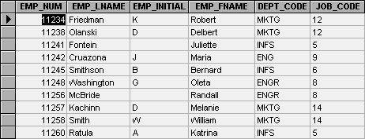

propose:

- A primary key

EMP_NUM

- A candidate key (different from the primary key)

There is no acceptable candidate key.

- A foreign key (probable)

DEPT_CODE

- A super key (different from the primary key)

EMP_NUM + EMP_LNAME

- A secondary key

EMP_LNAME + EMP_FNAME

- Draw an ERD with Crow’s foot model notation that satisfies the following business rules (note composite entities, weak entities, strong and weak relationships, and cardinalities).
Note: entities to represent are written in capital letters.

- An INVOICE is written by a SALESREP. Each sales representative can write many invoices, but each invoice is written by a single sales representative.

- The INVOICE is written for a single CUSTOMER. However, each customer can have many invoices.

- An INVOICE may include many detail lines (LINE) which describe the PRODUCTs bought by the customer.

- An invoice LINE references one PRODUCT, and a PRODUCT may be referenced in one or more invoice LINEs.

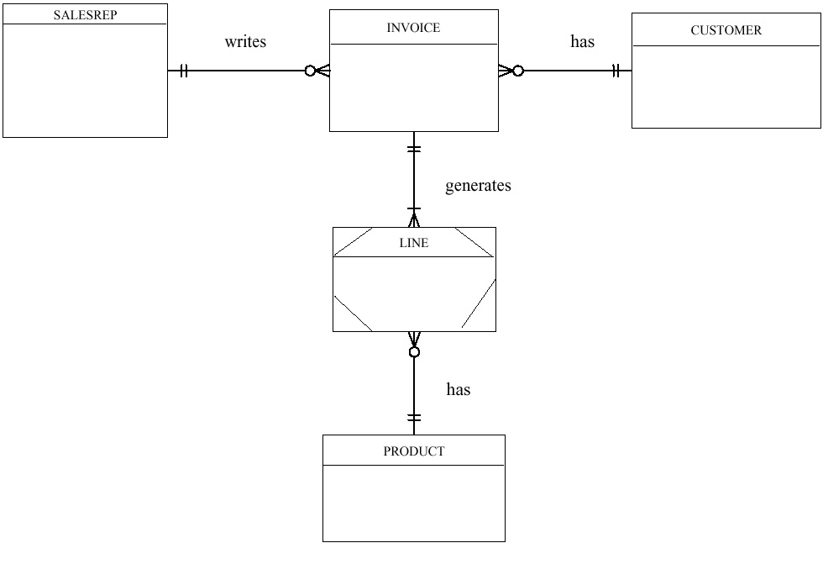

- Given the following dependency diagram:

Propose a set of relations that is in 3NF, such as Relation1(C1, C2, C3) …

Relation1(C1, C2)

Relation2(C1, C3, C4)

Relation3(C4, C5)

