**How to Use SPSS for Classification**

This handout explains how to use SPSS for classification tasks. We will see three methods for classification tasks, and how to interpret the results: binary logistic regression, multinomial regression, and nearest neighbor.

**Binary Logistic Regression**

**Input data characteristics**

It assumes that the dependent variable is dichotomic (Boolean).

The independent variables (predictors) are either dichotomic or numeric.

It is recommended to have at least 20 cases per predictor (independent variable).

**Steps to run in SPSS**

1. Select **Analyze 🡪 Regression 🡪 Binary Logistic**.

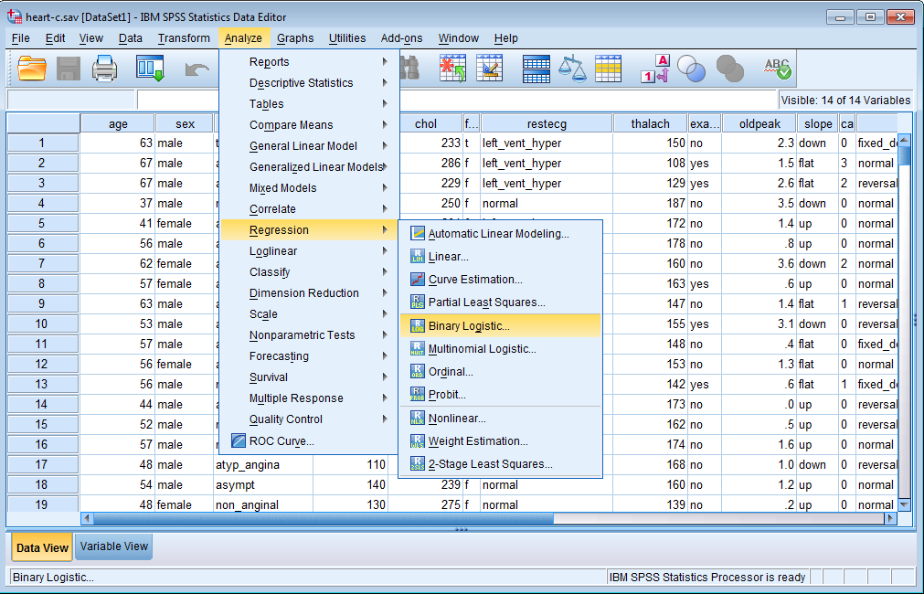

1. Select the dependent variable and the independent variables, and the selected method (**Enter** for example, which is the default).

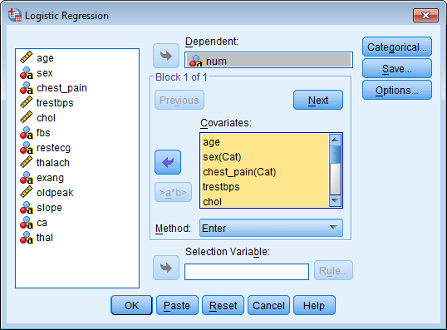

1. Select the options in the **Options** menu and select **95** as **CI for exp(B)**, which will provide confidence intervals for the odds ratio of the different predictors. Then click **Continue**.

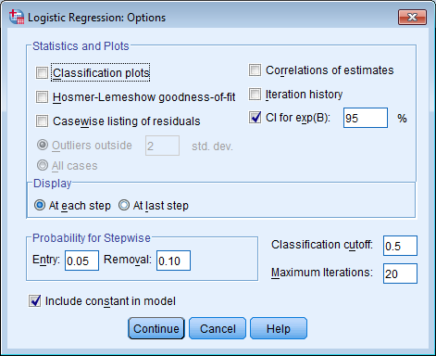

1. Click **OK**.

**Results interpretation**

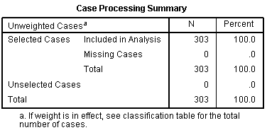

No participant has missing data

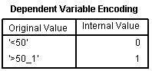

*Num* is the dependent variable and is coed 0 or 1

**Block 0: Beginning Block**

|  |  |  |  |  |  |
| --- | --- | --- | --- | --- | --- |
| **Classification Tablea,b** | | | | | |
|  | Observed | | Predicted | | |
|  | num | | Percentage Correct |
|  | '<50' | '>50_1' |
| Step 0 | num | '<50' | 165 | 0 | 100.0 |
| '>50_1' | 138 | 0 | .0  Predicting *num* without the predictors would provide 54.3% accuracy |
| Overall Percentage | |  |  | 54.5 |
| a. Constant is included in the model.  b. The cut value is .500 | | | | | |

Without using the predictors, we could predict that no participant has heart disease with 54.3% accuracy – which is not significantly different from 50-50 (i.e, no better than chance).

|  |  |  |  |  |  |
| --- | --- | --- | --- | --- | --- |
| **Variables not in the Equation** | | | | | |
|  | | | Score | df | Sig. |
| Step 0 | Variables | age | 15.399 | 1 | .000  *Age* is significantly related to *num*. |
| sex(1) | 23.914 | 1 | .000 |
| chest_pain | 81.686 | 3 | .000 |
| chest_pain(1) | 80.680 | 1 | .000 |
| chest_pain(2) | 18.318 | 1 | .000 |
| chest_pain(3) | 30.399 | 1 | .000 |
| trestbps | 6.365 | 1 | .012 |
| chol | 2.202 | 1 | .138 |
| fbs(1) | .238 | 1 | .625 |
| restecg | 10.023 | 2 | .007 |
| restecg(1) | 7.735 | 1 | .005 |
| restecg(2) | 9.314 | 1 | .002 |
| thalach | 53.893 | 1 | .000 |
| exang(1) | 57.799 | 1 | .000 |
| oldpeak | 56.206 | 1 | .000 |
| slope | 47.507 | 2 | .000 |
| slope(1) | 1.224 | 1 | .269 |
| slope(2) | 39.718 | 1 | .000 |
| ca | 74.367 | 4 | .000 |
| ca(1) | 1.338 | 1 | .247 |
| ca(2) | 65.683 | 1 | .000 |
| ca(3) | 16.367 | 1 | .000 |
| ca(4) | 22.748 | 1 | .000 |
| thal | 85.304 | 3 | .000 |
| thal(1) | .016 | 1 | .899 |
| thal(2) | 3.442 | 1 | .064 |
| thal(3) | 84.258 | 1 | .000 |
| Overall Statistics | | 176.289 | 22 | .000 |

Many variables are separately significantly related to *num*. All variables with Sig. less than or equal to 0.05 are significant predictors of whether a person has heart disease. There are 11 of these significant predictors here: age, sex, chest_pain, trestbps, restecg, thalach, exang, oldpeak, slope, ca, thal.

**Block 1: Method = Enter**

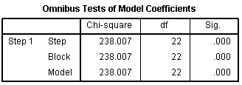

The model is significant when all independent variables are entered (Sig <= 0.05).

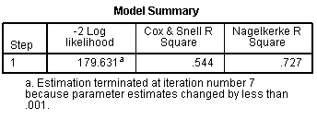

72.7% of the variance in *num* can be predicted from the combination of the independent variables.

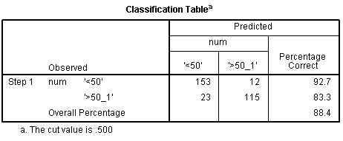

88.4% of the subjects were correctly classified by the model.

|  |  |  |  |  |  |  |  |  |  |
| --- | --- | --- | --- | --- | --- | --- | --- | --- | --- |
| **Variables in the Equation** | | | | | | | | | |
|  | | B | S.E. | Wald | df | Sig. | Exp(B) | 95% C.I.for EXP(B) | |
| Lower | Upper |
| Step 1a | age | -.028 | .025 | 1.197 | 1 | .274 | .973 | .925 | 1.022 |
| sex(1) | -1.862 | .571 | 10.643 | 1 | .001 | .155 | .051 | .475 |
| chest_pain |  |  | 18.539 | 3 | .000 |  |  |  |
| chest_pain(1) | 2.417 | .719 | 11.294 | 1 | .001 | 11.213 | 2.738 | 45.916 |
| chest_pain(2) | 1.552 | .823 | 3.558 | 1 | .059 | 4.723 | .941 | 23.698 |
| chest_pain(3) | .414 | .707 | .343 | 1 | .558 | 1.513 | .378 | 6.050 |
| trestbps | .026 | .012 | 4.799 | 1 | .028 | 1.027 | 1.003 | 1.051 |
| chol | .004 | .004 | 1.022 | 1 | .312 | 1.004 | .996 | 1.013 |
| fbs(1) | .446 | .588 | .574 | 1 | .448 | 1.562 | .493 | 4.944 |
| restecg |  |  | 1.443 | 2 | .486 |  |  |  |
| restecg(1) | -.714 | 2.769 | .067 | 1 | .796 | .490 | .002 | 111.371 |
| restecg(2) | -1.175 | 2.770 | .180 | 1 | .672 | .309 | .001 | 70.447 |
| thalach | -.020 | .012 | 2.860 | 1 | .091 | .980 | .958 | 1.003 |
| exang(1) | -.779 | .452 | 2.973 | 1 | .085 | .459 | .189 | 1.112 |
| oldpeak | .397 | .242 | 2.686 | 1 | .101 | 1.488 | .925 | 2.392 |
| slope |  |  | 8.861 | 2 | .012 |  |  |  |
| slope(1) | .690 | .948 | .530 | 1 | .467 | 1.994 | .311 | 12.773 |
| slope(2) | 1.465 | .498 | 8.645 | 1 | .003 | 4.328 | 1.630 | 11.492 |
| ca |  |  | 30.907 | 4 | .000 |  |  |  |
| ca(1) | -3.515 | 1.926 | 3.331 | 1 | .068 | .030 | .001 | 1.297 |
| ca(2) | -2.247 | .938 | 5.744 | 1 | .017 | .106 | .017 | .664 |
| ca(3) | .095 | .958 | .010 | 1 | .921 | 1.100 | .168 | 7.196 |
| ca(4) | 1.236 | 1.141 | 1.174 | 1 | .279 | 3.442 | .368 | 32.212 |
| thal |  |  | 13.010 | 3 | .005 |  |  |  |
| thal(1) | .915 | 2.600 | .124 | 1 | .725 | 2.497 | .015 | 408.255 |
| thal(2) | -1.722 | .809 | 4.537 | 1 | .033 | .179 | .037 | .871 |
| thal(3) | -1.453 | .445 | 10.665 | 1 | .001 | .234 | .098 | .559 |
| Constant | .956 | 4.131 | .054 | 1 | .817 | 2.601 |  |  |
| a. Variable(s) entered on step 1: age, sex, chest_pain, trestbps, chol, fbs, restecg, thalach, exang, oldpeak, slope, ca, thal. | | | | | | | | | |

Many variables are significantly related to *num* when all the 13 variables are taken together. All variables with Sig. less than or equal to 0.05 are significant predictors of whether a person has heart disease. There are 6 of these significant predictors here: sex, chest_pain, trestbps, slope, ca, thal.

This suggests some correlation among predictors since that age, restecg, thalach, exang, oldpeak were significant predictors when used alone.

Fbs and chol are not predictors of the severity of heart disease.

**Results write-up**: Logistic regression was conducted to assess whether the thirteen predictor variables … significantly predicted whether or not a subject has heart disease. When all predictors are considered together, they significantly predict whether or not a subject has heart disease, chi-square = 238, df = 22, N = 303, p < .001. The classification accuracy is 88.4%. Table 1 presents the odd ratios of the major predictors, which suggests that the odds of estimating correctly who has heart disease improve significantly if one knows sex, chest_pain, trestbps, slope, ca, and thal.

Table 1.

|  |  |  |
| --- | --- | --- |
| **Variable** | **Odds ratio** | **p** |
| Sex | 0.16 | .001 |
| chest_pain (1) | 11.21 | .001 |
| trestbps | 1.03 | .028 |
| slope (2) | 4.33 | .003 |
| ca (1) | 0.07 | .030 |
| thal (1) | .73 | .015 |

**Binary Logistic Regression with Independent Training and Test Sets**

One can repeat the previous experience, but after splitting the dataset into a training set (75% of the data) and a test set (25% of the data).

**Steps to run in SPSS**

1. Set the random seed number to ***Random*** (or you can select a predefined value): **Transform 🡪 Random Number Generators 🡪 Set Starting Point**

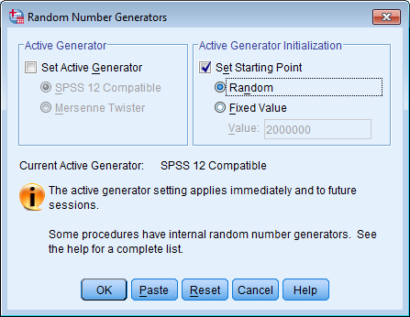

1. Create a ***split*** variable which will be set to ***1*** for 75% of the cases, randomly selected, and to ***0*** for 25% of the cases.  
   **Transform 🡪 Compute Variable 🡪 split = uniform(1) <= 75**

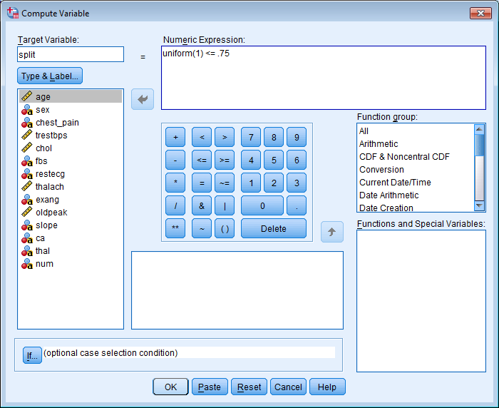

1. Recall the Logistic Regression experiment from the **Recall** icon.

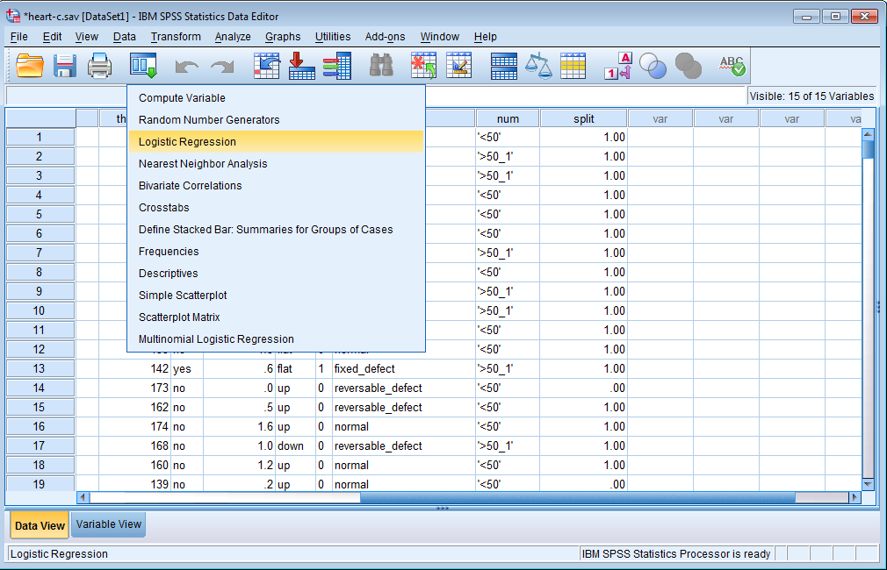

1. Repeat the regression as before, except that the **Selection Variable** is chosen as the **split** variable and the **value 1** is selected for this variable under **Rule**.

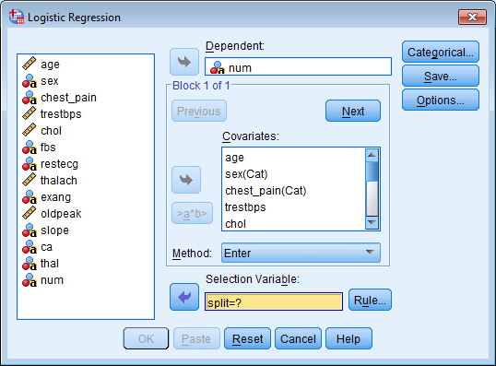

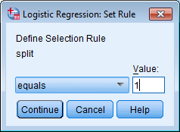

1. Click on **OK** to run the **Binary Logistic regression.**

**Results interpretation**

**Block 1: Method = Enter**

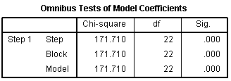

The model is significant when all independent variables are entered (Sig < 0.01).



72.7% of the variance in *num* can be predicted from the combination of the independent variables.

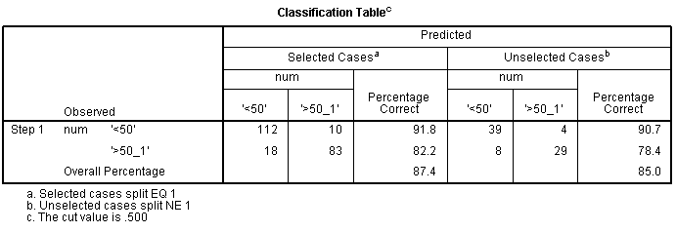

85.0% of the test subjects were correctly classified by the model.

The classification rate in the holdout sample is within 10% of the training sample

(87.4% * 0.9).

This is sufficient evidence of the utility of the logistic regression model.

The 6 significant predictors are the same: sex, chest_pain, trestbps, slope, ca, thal.

**Results write-up**: By splitting the dataset into 75% training set and 25% test set, the accuracy in the holdout sample changes to 85.0%, which is within 10% of the training sample. The significant predictors remain the same as in the model of the entire dataset. These results reinforce the utility of the logistic regression model.

**Nearest Neighbor**

**Input data characteristics**

It assumes that the dependent variable is dichotomic (Boolean).

The independent variables (predictors) are either dichotomic or numeric.

It is recommended to have at least 20 cases per predictor (independent variable).

**Steps to run in SPSS**

1. Select **Analyze 🡪 Classify 🡪 Nearest Neighbor**.

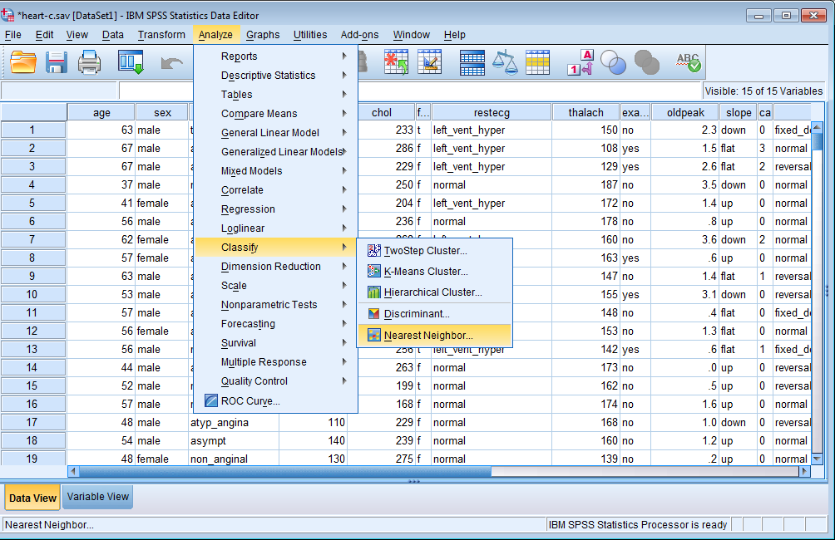

1. Select the target variable and the features (or factors).

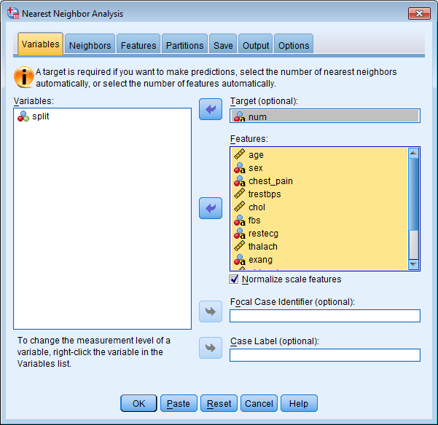

1. You may change other options, such as the number of neighbors (**Neighbors** tab), the distance metric, feature selection (**Features** tab), and the Partitions (**Partitions** tab). We select here to split the training set (75%) and the test set (25%).  
   Other options on this page are the 10-fold cross validation, which yields a more robust evaluation.

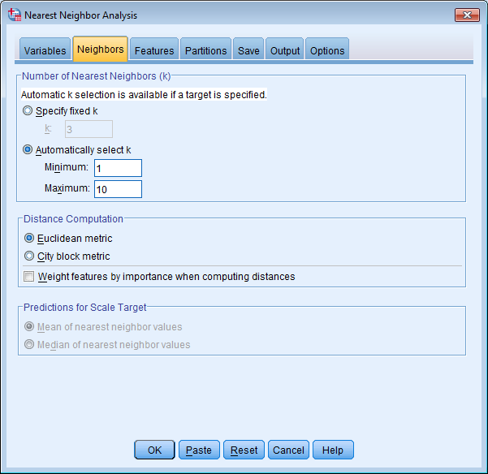

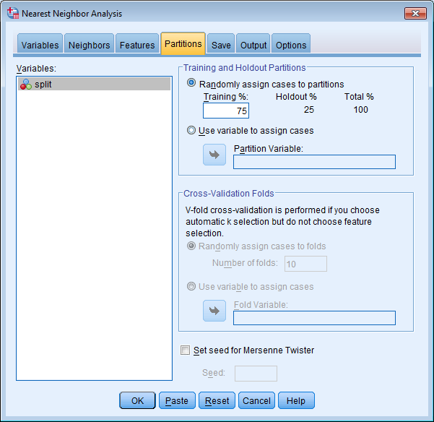

1. Click **OK**.

**Results interpretation**

The classification accuracy is found in the model viewer by double-clicking the chart obtained and looking at the classification table, which shows an accuracy of 87.2% for K = 5.

|  |  |  |  |  |
| --- | --- | --- | --- | --- |
| **Classification Table** | | | | |
| **Partition** | **Observed** | **Predicted** | | |
| **'<50'** | **'>50_1'** | **Percent Correct** |
| **Training** | **'<50'** | 100 | 16 | 86.2% |
| **'>50_1'** | 23 | 78 | 77.2% |
| **Overall Percent** | 56.7% | 43.3% | 82.0% |
| **Holdout** | **'<50'** | 43 | 6 | 87.8% |
| **'>50_1'** | 5 | 32 | 86.5% |
| **Missing** | 0 | 0 |  |
| **Overall Percent** | 55.8% | 44.2% | 87.2% |

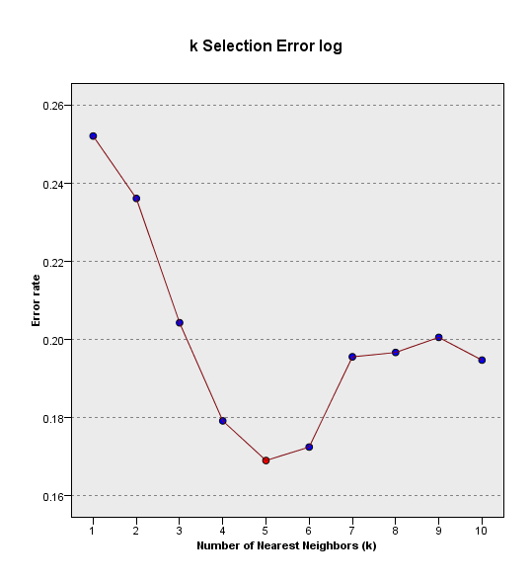

Classification accuracy.

**Results write-up**: Nearest neighbor classification with k= 3 (3NN) was conducted to assess whether the thirteen predictor variables correctly predicted whether or not a subject has heart disease. When all predictors are considered together, 87.2% of the subjects were correctly classified.